Nhat Doan_ CSC134_Midterm_Question 4

4. Mapping the following ER design into the relational model. (30 points)

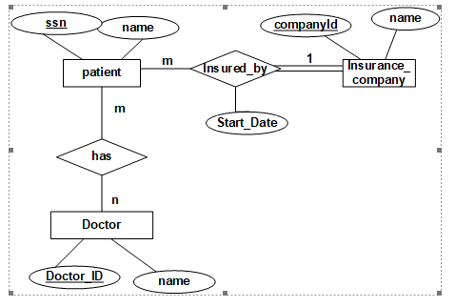

Answer:

Insurrance_Company ( companyID , name)



Patient ( SSN , name , insurance_company_id , Start_ Date )



Has_Dr_Patient ( Patient_SSN , Doctor ID )



Doctor ( Doctor ID , name)